BOARD OF ASSESSORS
MINUTES OF MEETING
March 11, 2024 @ 4:00 PM

Members Present: Robert Ortiz, Pamela Woodbury & Nancy Herholz
Principal Assessor, Linda LeBlanc
Meeting called to order @ 4:00 pm
Our next Board Meeting will be held on Monday, April 8 at 4:00 pm
The Board voted to approve the minutes for February 12, 2024 Vote (2-0)
Pam abstained
Motor Vehicle: Vote (3-0)

The Board voted to approve sixty-four abatement applications

The Board voted to approve February’s monthly list of abatements for 2023 $451.38

The Board voted to approve February’s monthly list of abatements for 2024 $6,511.63

The Board voted to approve the commitment and warrant for 2024-02 $193,466.81
Real Estate: Vote (3-0)
The Board voted to approve February’s monthly list of exemptions and abatements for FY24 $16,025.69
Chapterland:
The Board gave Linda permission to sign and record the lien for Adam Watson on R15/2

Old Business: Vote (3-0)

The issue with the address change request on 7 Washburn Drive was discussed and the Board voted not to change the address due to police and fire (911) knowing the property as 7 Washburn Drive for the last 30 or 40 years, along with all the recorded deeds and plans describing the property as 7 Washburn Drive.

New Business:

The Board was made aware of the public information request for Jonathan Karbowski at 14 Marble Road and the fact that his motor vehicle excise tax bill was returned unpaid with “This is extortion and mail fraud” written on it.

The meeting was continued to have our executive session meeting and was reconvened and adjourned at 4:35 pm.

Executive Session:
The Board needs to enter executive session G.L. c. 30A, §21 (a) purpose 7 - To comply with, or act under the authority of, any general or special law or federal grant-in-aid requirements, citing the statutory right to privacy to discuss Applications for Statutory Exemptions (Ch 59 § 60). See general Laws Chapter 59 § 32 for Schedules not open to public inspection.
Real Estate Exemptions:
The Board voted to approve the following 41C Elderly exemption applications for FY24 in the amount of $500.00;
- U22/87 Diane Calvano
The Board voted to approve the following 22a-e Veterans exemption applications for FY24 in the amount of $400.00;
- R56/46 Craig Manfield

BOARD OF ASSESSORS
MINUTES OF MEETING
March 11, 2024 @ 4:00 PM
(Continued)

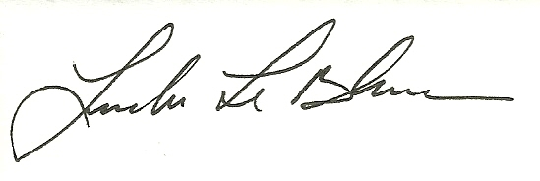
Linda LeBlanc, MAA

